Figure 1. Examples of the beer bottles used in the experiment which vary in the size (small vs. large), format (text-only vs. traffic light) and alcohol strength (0.4%, 4.6% and 15%) of the Alcohol by Volume (ABV) label.
Within subject factor (alcohol strength)
0.4% |  |  |  | 4.6% |  |  |  |  | 15%
Between subject factors (size and format)
Small |  | Large |  | Small | Large |  | Small | Large | Small | Large | Small |  | Large
Text-only | Traffic light | Text-only | Traffic light | Text-only | Traffic light |  | Text-only | Traffic light | Text-only | Traffic light | Text-only | Traffic light
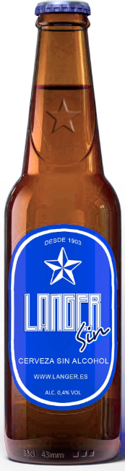 | 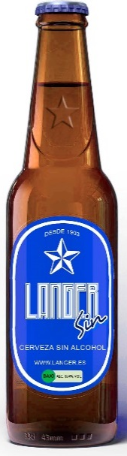 | 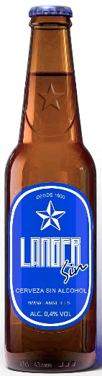 | 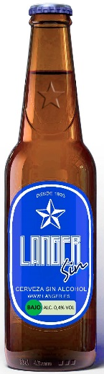 | 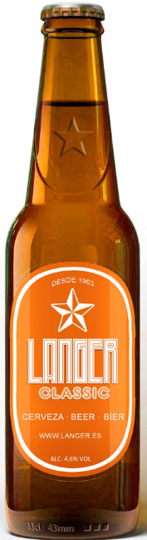 | 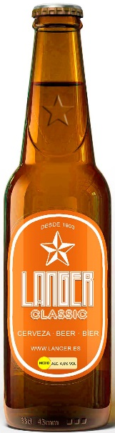 | 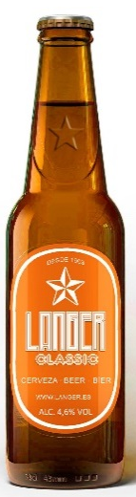 |  | 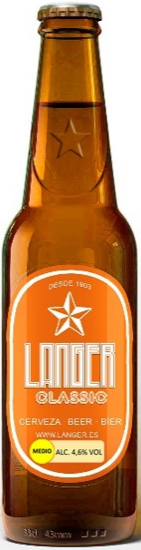 | 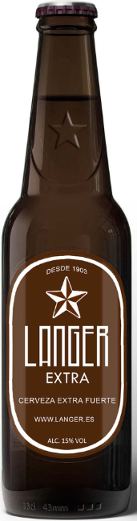 | 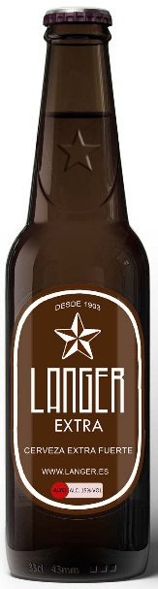 | 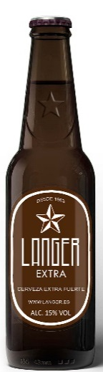 | 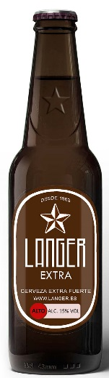

Figure 2. Examples of the beer bottles presented to a sub-sample of participants, including a small or large warning label.
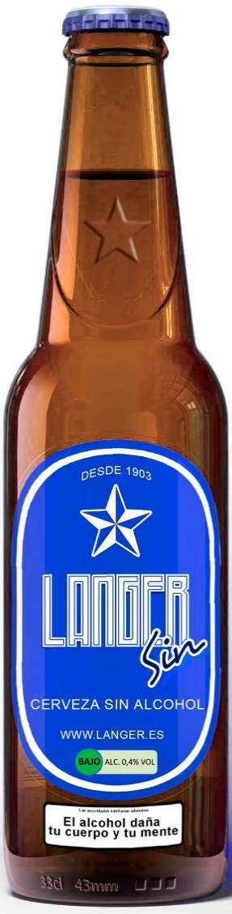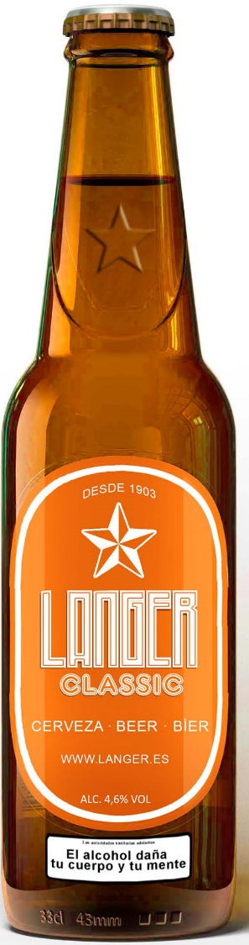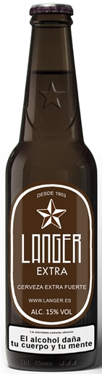

Figure 3. Examples of three different adverts used.
