Appendix 1
Figure A1. Alcoholic beverage trends and periods of changes identified by sensitive analysis.
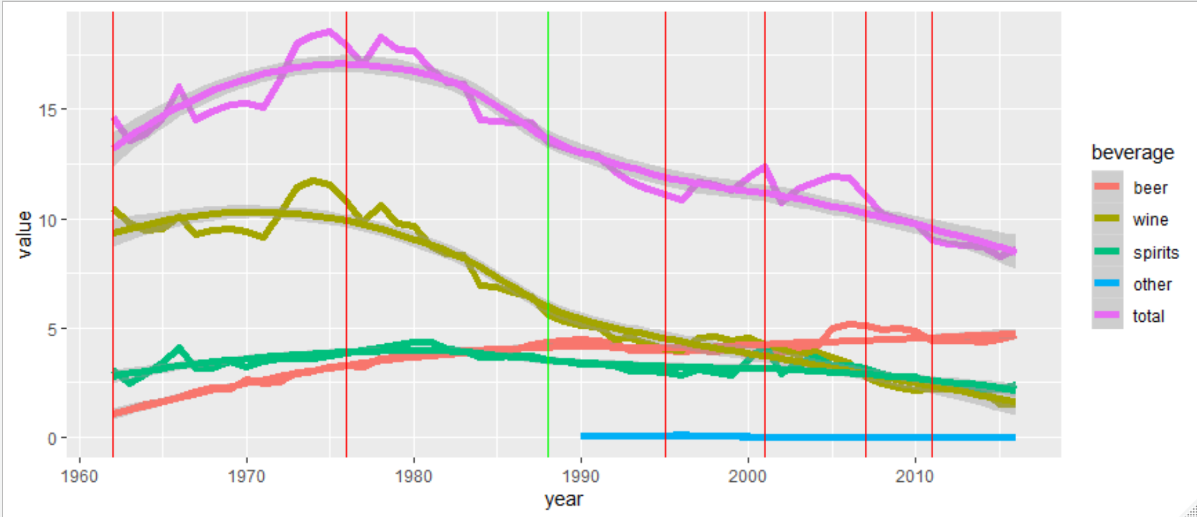
Table A1.
Data on alcohol per capita consumption by year, type of alcoholic beverage and source.
Year | Wine | Beer | Spirits | Other | Total | Source
1962 | 10.49 | 1.05 | 3.10 |  | 14.64 | Matrai
1963 | 9.81 | 1.27 | 2.48 |  | 13.56 | Matrai
1964 | 9.50 | 1.49 | 2.89 |  | 13.88 | Matrai
1965 | 9.54 | 1.61 | 3.44 |  | 14.59 | Matrai
1966 | 10.08 | 1.82 | 4.13 |  | 16.03 | Matrai
1967 | 9.26 | 2.10 | 3.18 |  | 14.54 | Matrai
1968 | 9.45 | 2.28 | 3.18 |  | 14.91 | Matrai
1969 | 9.53 | 2.22 | 3.47 |  | 15.22 | Matrai
1970 | 9.39 | 2.67 | 3.19 |  | 15.25 | Matrai
1971 | 9.16 | 2.48 | 3.47 |  | 15.11 | Matrai
1972 | 10.22 | 2.50 | 3.61 |  | 16.33 | Matrai
1973 | 11.43 | 2.95 | 3.60 |  | 17.98 | Matrai
1974 | 11.72 | 3.06 | 3.60 |  | 18.38 | Matrai
1975 | 11.55 | 3.25 | 3.73 |  | 18.53 | Matrai
1976 | 10.77 | 3.30 | 3.86 |  | 17.93 | Matrai
1977 | 9.85 | 3.23 | 3.99 |  | 17.07 | Matrai
1978 | 10.58 | 3.58 | 4.12 |  | 18.28 | Matrai
1979 | 9.79 | 3.68 | 4.24 |  | 17.71 | Matrai
1980 | 9.69 | 3.64 | 4.36 |  | 17.69 | Matrai
1981 | 8.78 | 3.73 | 4.33 |  | 16.84 | Matrai
1982 | 8.40 | 3.81 | 4.02 |  | 16.23 | Matrai
1983 | 8.32 | 3.88 | 3.98 |  | 16.18 | Matrai
1984 | 6.94 | 3.87 | 3.68 |  | 14.49 | Matrai
1985 | 6.86 | 3.97 | 3.64 |  | 14.47 | Matrai
1986 | 6.65 | 3.99 | 3.73 |  | 14.37 | Matrai
1987 | 6.45 | 4.26 | 3.70 |  | 14.41 | Matrai
1988 | 5.64 | 4.34 | 3.54 |  | 13.52 | Matrai
1989 | 5.33 | 4.45 | 3.50 |  | 13.28 | Matrai
1990 | 5.10 | 4.46 | 3.35 | 0.07 | 14.18 | GISAH
1991 | 5.07 | 4.39 | 3.34 | 0.08 | 13.91 | GISAH
1992 | 4.49 | 4.32 | 3.31 | 0.07 | 13.43 | GISAH
1993 | 4.56 | 4.00 | 3.04 | 0.07 | 12.88 | GISAH
1994 | 4.27 | 3.99 | 3.02 | 0.08 | 12.47 | GISAH
1995 | 4.03 | 3.99 | 2.99 | 0.08 | 12.14 | GISAH
1996 | 3.97 | 3.93 | 2.86 | 0.10 | 12.23 | GISAH
1997 | 4.57 | 3.95 | 3.08 | 0.09 | 12.38 | GISAH
1998 | 4.62 | 3.94 | 2.95 | 0.07 | 12.57 | GISAH
1999 | 4.39 | 4.06 | 2.82 | 0.06 | 12.66 | GISAH
2000 | 4.53 | 3.79 | 3.52 |  | 12.96 | GISAH
2001 | 4.20 | 3.91 | 4.23 |  | 12.77 | GISAH
2002 | 4.02 | 3.83 | 2.89 |  | 12.59 | GISAH
2003 | 3.82 | 4.11 | 3.42 |  | 12.35 | GISAH
2004 | 3.89 | 4.10 | 3.69 |  | 12.78 | GISAH
2005 | 3.67 | 4.98 | 3.27 |  | 12.96 | GISAH
2006 | 3.43 | 5.15 | 3.28 |  | 12.73 | GISAH
2007 | 2.78 | 5.09 | 3.18 |  | 12.12 | GISAH
2008 | 2.44 | 4.92 | 2.88 |  | 11.43 | GISAH
2009 | 2.28 | 4.98 | 2.73 |  | 10.97 | GISAH
2010 | 2.15 | 4.87 | 2.76 |  | 10.52 | GISAH
2011 | 2.20 | 4.40 | 2.42 |  | 10.24 | GISAH
2012 | 2.21 | 4.41 | 2.20 |  | 10.01 | GISAH
2013 | 2.15 | 4.42 | 2.20 |  | 10.04 | GISAH
2014 | 2.16 | 4.35 | 2.18 |  | 9.97 | GISAH
2015 | 1.55 | 4.51 | 2.21 |  | 10.04 | GISAH
2016 | 1.55 | 4.64 | 2.39 |  | 9.93 | GISAH
2017 |  |  |  |  | 10.00 | Manthey
2018 |  |  |  |  | 9.93 | Manthey
2019 |  |  |  |  | 9.91 | Manthey

